Case Fossil-Afr-Morocco-Atlas Mtns-Boulalou-Stromatolite-Cretaceous period-100 mya

Weighing 2 pounds .3 ounces

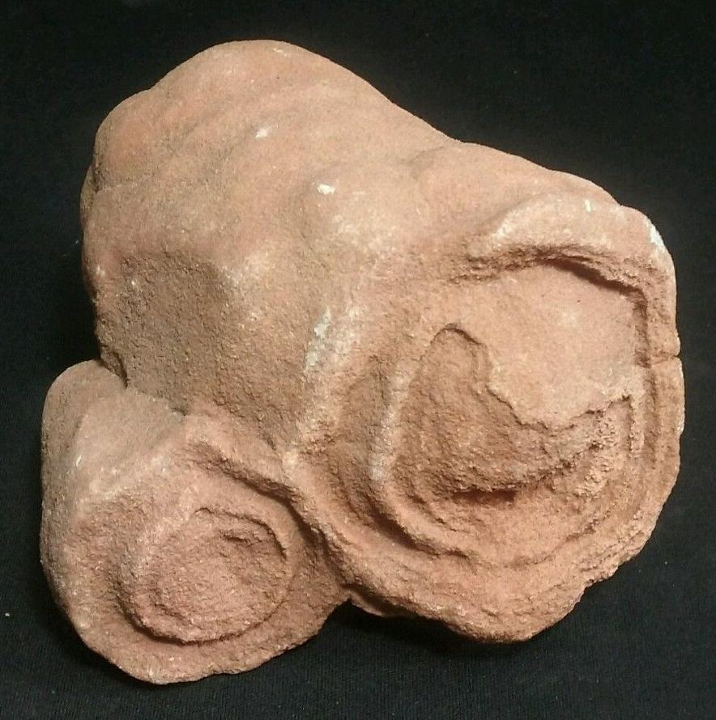 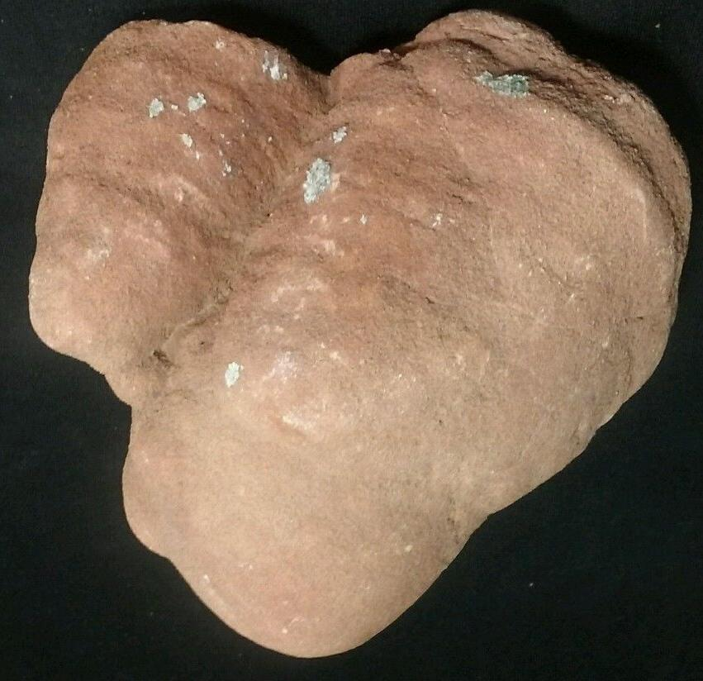

# Order details

## Sales order

Sold by [flower2992](http://myworld.ebay.com/flower2992) ( [258](http://feedback.ebay.com/ws/eBayISAPI.dll?ViewFeedback&userid=flower2992) )

### Delivery package 1 of 1

Estimated delivery Saturday, Jan 2, 2016 - Wednesday, Jan 6, 2016

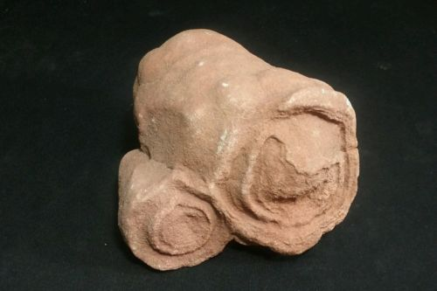

#### [Stromatolite Fossil Algae- Sahara - 2 pound .3 oz. Double colony](http://www.ebay.com/itm/262195730449)

|  |  |
| --- | --- |
| Item price | $27.99 |
| Quantity | 1 |
| Item number | 262195730449 |
| Shipping service | USPS Priority Mail |

## Shipping address

Ralph J Coffman Jr

149 Atlantic Ave

Swampscott MA 01907-2427

United States

## Order total

|  |  |
| --- | --- |
| Subtotal | $27.99 |
| Shipping | $6.00 |

**Total**

$33.99